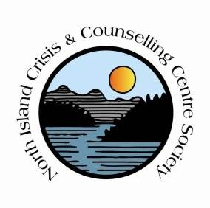
North Island Crisis and Counselling Centre Society
Job Opportunity
Women’s Counsellor (fulltime, temporary)
Reporting to the Executive Director, the Women’s Counsellor provides counselling to women who are experiencing, or have experienced violence or trauma in their lives. The position aids the clients in identifying, understanding and overcoming the effects of violence and in establishing and achieving realistic goals for themselves.

Key duties and responsibilities
- Within a feminist context, develops and implements counselling and intervention protocols to assist clients in determining goals and the means of obtaining them.
- Plan, prepare and conduct individual or group counselling sessions with clients, and develop and implement a plan for therapy through a variety of modalities, including psycho-education.
- Educate the community on domestic violence and its effects through workshops and presentations.
- Collaborate with local Indigenous organizations & communities to provide culturally safe services that acknowledge the historical and systemic trauma that impacts their lives.
- Provide support and acts as the client’s advocate throughout service, and, as appropriate, provide follow-up support to them upon leaving the program.
Abilities/skills/knowledge
  - Well-developed interpersonal, counselling, oral and written communication skills
  - Good organization, time and general management skills
  - Demonstrated knowledge of counselling within a feminist perspective
  - Demonstrated knowledge of concepts and skills in working with women who are experiencing, or have experienced, violence in their lives
  - Strong initiative and work ethic
  - Good team work skills
  - Group facilitation skills; demonstrates knowledge of group processes and adult learning styles

Qualifications
- Bachelor’s degree in related field
- Minimum 2 years supervised experience counselling within a feminist context

Terms of Employment:
Temporary fulltime position, 35 hours per week, likely to last past March 2019;
Valid BC Driver’s license and use of personal vehicle equipped with winter tires Oct 1 – Mar 31;
Clean criminal record check;
Salary based on qualifications and experience

Applications to:
Executive Director
chrisp@nicccs.org

For more information please call NICCCS office at 250-949-8333

