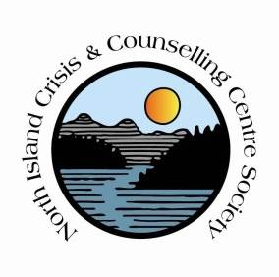
North Island Crisis and Counselling Centre Society
Job Opportunity
Sexual Abuse Intervention Program Counsellor (fulltime)

Reporting to the Executive Director, the Sexual Abuse Intervention Counsellor provides sexual abuse intervention services to children and youth under the age of 19; and may work with children under the age of 12 who have sexual behaviour problems related to sexual abuse or exploitation experiences.
The SAIP Counsellor provides support and education for family members and works toward the prevention of future abuse.
Key duties and responsibilities
- Conduct screening and assessment to determine eligibility, prioritize cases and determine the nature and severity of sexual abuse.
- Conduct a comprehensive assessment; use methods and instruments recognized in the sexual abuse field: Ministry of Children and Family Development (MCFD) SAIP Standards.
- Use information derived from screening & assessment process to refer children/youth whose clinical needs are beyond the scope that SAIP Counsellor can provide.
- Develop a treatment/support plan with the child/youth or guardian, with measureable and realistic goals.
Abilities/skills/knowledge
- Excellent organizational, communication and interpersonal skills.
- Ability to create and maintain a welcoming, friendly , safe environment
- Affirms and promotes the dignity of children and adults with diverse backgrounds, interests and needs.
- Promotes and reinforces socially responsible behaviour
- In-depth knowledge of child development, sexual abuse dynamics, family systems and mental health issues.
- Training and experience in expressive, behavioural and cognitive modalities.
- Knowledge of child protection and legal systems.
- Basic computer knowledge and skills.

Qualifications
- Master’s degree in child and youth, counselling, social work or related field.
- A minimum 2 years counselling experience with children, youth and families.
- Preference if candidate has specialized training to assess and treat sexualized children
- Expressive arts therapy (play, art, drama) is considered to be an asset

Terms of Employment:
Permanent position, 35 hours per week;
Valid BC Driver’s license and use of personal vehicle equipped with winter tires Oct 1 – Mar 31;
Clean criminal record check;
Salary based on qualifications and experience

Applications to:
Executive Director
chrisp@nicccs.org

For more information please call NICCCS office at 250-949-8333

