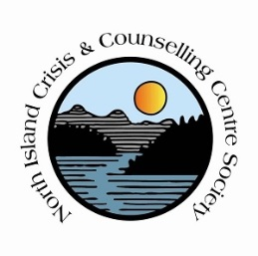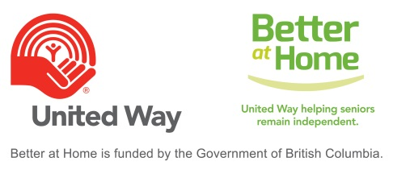

We are Hiring, Please Share
Housekeeping – Better at Home Program
This is a client based housekeeping position, in the COAL HARBOUR area for an individual who is interested in making a difference in the lives of seniors/elders and being part of the BAH Team.
The Better at Home program helps seniors with light housekeeping so that they can continue to live independently in their own homes and remain connected to their communities.
Duties include assisting seniors/elders with house cleaning such as bathrooms, floors, vacuuming and other household chores.
Better at Home housekeepers are required to complete a criminal record check, and supply two personal references. Previous job experience is an asset. Wage is $20/hr.
A valid class 5 driver’s license and reliable vehicle is an asset, and may be required depending on applicant. Housekeepers are required to manage housekeeping schedule with clients, as well communicating effectively with Program Coordinator.
Please email resume to North Island Crisis and Counselling Centre at tammym@nicccs.org (subject line must read BAH Housekeeping Resume)

